

**AMERICAN INTERNATIONAL UNIVERSITY-BANGLADESH**

**DIGITAL LOGIC DESIGN LABORATORY**

**Experiment No:** 01

**Section:** B

**Semester:** Fall 2021-22

**Experiment Name: Studying different digital Integrated Circuits (ICs)**

**Submitted by: Rishad, Md. Yashir Arafat**

## Submitted to: Dr. Ferdous Jahan Shaun

## Date of Experiment: 13-September-2021

## Date of Submission: 20-September-2021

**Group No: C**

|  |  |  |  |
| --- | --- | --- | --- |
| **SL NO** | **NAME** | **ID** | **Department** |
| 1 | Rishad, Md. Yashir Arafat | 18-37677-1 | CSE |
| 2 | Pshan, Mahathir Shams | 18-37220-1 | CSE |
| 3 | Md Saiful Islam | 18-36363-1 | CSE |
| 4 | Sadek Islam | 17-35436-3 | CSE |
| 5 | Izu, Humam Ahmed | 17-34148-1 | CSE |
| 6 | Moktadir, Md. Golam | 18-37211-1 | CSE |
| 7 | Sunny, Fazle Rabbi | 16-32822-3 | CSSE |
| 8 | Pritom, Sadi Mohammed | 18-37236-1 | CSE |
| 9 | Rasel,Md. AMINUL | 18-37723-1 | CSE |

1. **Abstract:**

An integrated Circuit, or IC, is an electronic circuit constructed on a small piece of semiconducting material that performs the same function as a larger circuit made up of discrete components. We learned about many types of logic gates and used relevant integrated circuits (ICs) to test their truth tables. A logic gate is a fundamental component of a digital circuit.

1. **Objective:**

i). To become familiar with the digital trainer board and digital ICs, as well as to learn the properties of many logic gates.

ii). To put inputs and outputs to the test.

1. **Results:**
   1. Simulation Environment: Proteus Professional Software version 8.9 was utilized to simulate this assignment. 2D circuits can be constructed with this simulation software.
   2. Simulation Results:

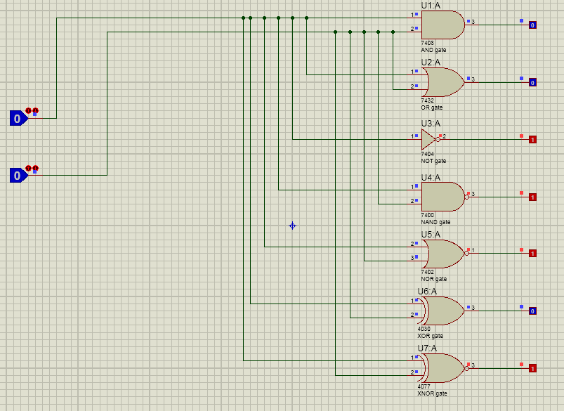

Figure 1: For Input A=0, Input B=0.

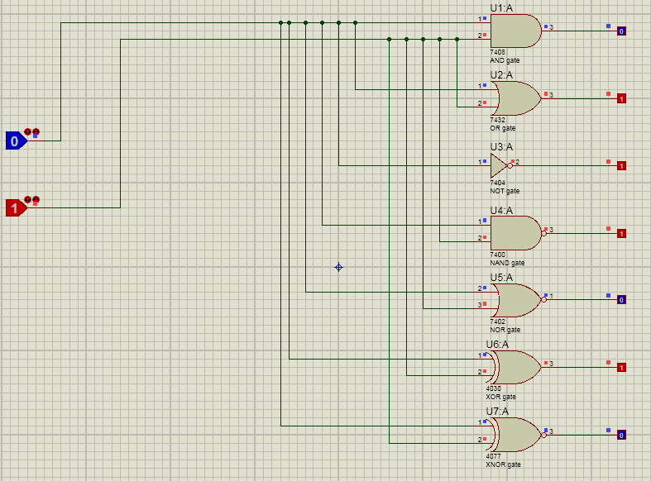

Figure 2: For Input A=0, Input B=1.

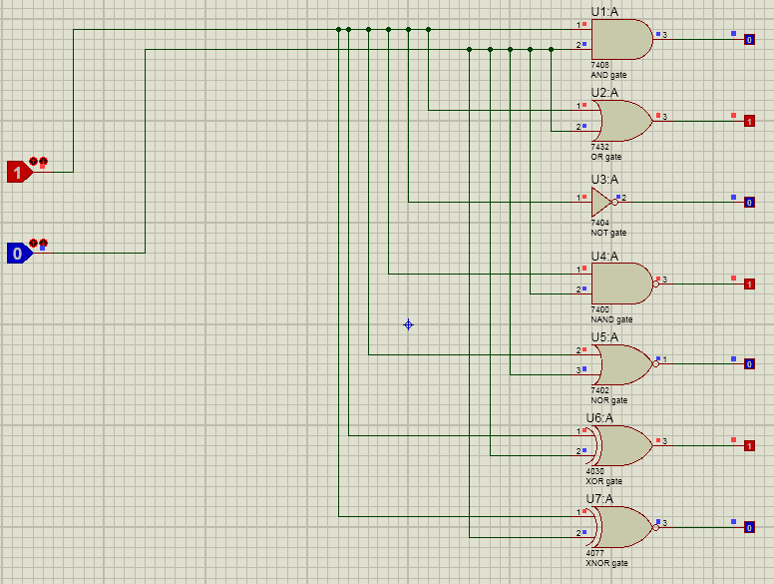

Figure 3: For Input A=1, Input B=0.

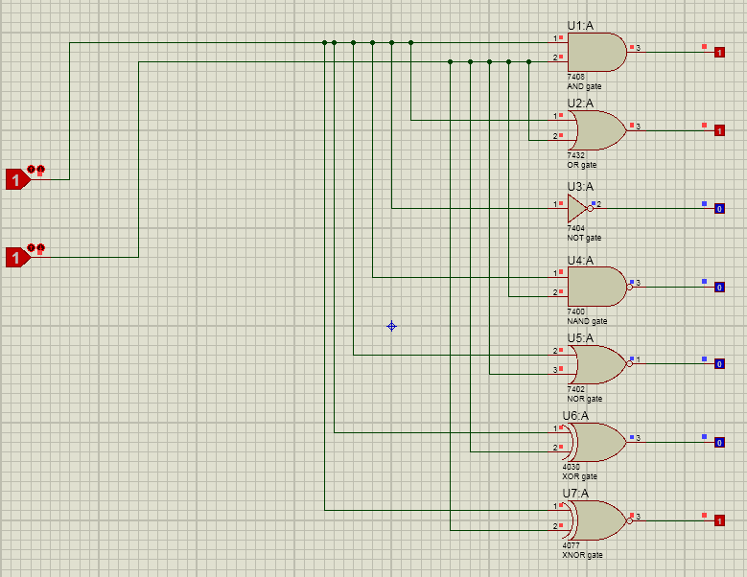

Figure 4: For Input A=1, Input B=1.

* 1. **Discussion:**

The primary goal of this experiment was to investigate several digital integrated circuits and verify various logic gates. By comparing theoretical and actual data, it can be concluded that both sets of data are same and that there are no inconsistencies. To ensure that all logic gates were built using dual inline package ICs, all logic gates were built using dual inline package ICs. For correct connection, all pin connections for all ICs were reviewed and understood. On simulation tools, all of the connections were meticulously established.

1. **Question Answer:**
2. **What do you mean by Vcc and ground of an IC?**

The voltage at collector is denoted by Vcc. Vcc is usually attached to an IC's common collector pin. The positive pin is usually used. Negative supply voltage is represented by an IC's ground. This is almost often the negative pin in digital logic. The majority of Ics run on 5V DC power.

1. **How to construct a 4 I/p AND gate by using 2 I/p AND gate?**

We'll need three 2 I/p AND gates to make a 4I/p AND gate. To link all four inputs, we must first utilize two 2 I/p AND gates. The outputs of these AND gates should then be connected to the third 2 I/p AND gate's input. We can make a 4 I/p AND gate out of a 2 I/p AND gate this way.

1. **From the truth table of an X-OR gate write the X-OR equivalent equation by using NOT, OR and AND gate?**

We can make an XOR gate circuit using only AND, OR, and NOT gates.

(A \cdot \overline{B} + \overline{A} \cdot B ) will be the expression. This method, however, necessitates the use of five gates of these three sorts. We can make an XOR gate in this fashion.

1. **To construct a two –bit comparator (o/p will be high if the i/ps are equal) which gate is used?**

The XNOR gate can be used to create a two-bit comparator with a high output if the inputs are equal. When both inputs are the same or equal, the output of an XNOR gate is high.

1. **Conclusion**:

Each group member conducted all tests (simulations) on their own equipment. Working with genuine ICs was not possible due to the online class. All of the tests were completed successfully. This lab aided in a better understanding of the gates.

**Reference:**

1. AIUB Lab Manual

2. [www.idc-online.com](http://www.idc-online.com)

3. www.baeldung.com